Question:
Suppose that we have the following five points:
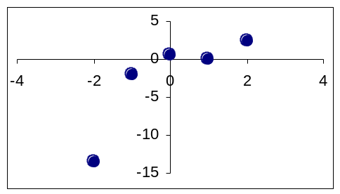
x | y
-2 | -13.5
-1 | -2.0
0 | 0.5
1 | 0.0
2 | 2.5

- First, find the 2nd-degree polynomial that best matches these points.
- Then, find the 3rd-degree polynomial that best matches these points.

Note that these points were selected to work out to relatively easy numbers (lots of zeros and multiples of 5), so you should be able to work out the answers by hand (perhaps with a little help from a calculator or Excel). In order to find the answers, you will need to:
- Calculate the values for the least squares formulas (x sums and y sums).
- Fill in the values to form the augmented matrix.
- Use Gaussian elimination to solve for the coefficients of the desired polynomials.
- Take the coefficients and form the desired least-squares polynomial.

You will need to go through each of these steps for both the 2nd- and 3rd-degree polynomials, although you will notice that a lot of the calculations from the 2nd-degree polynomial are simply repeated for the 3rd-degree polynomial.

Try to find the answers by hand (you should be able to do the Gaussian elimination by hand too!) first. Then use your code to check whether your answers are correct.

After you’ve tried to work out the answers yourself, take a look at the answers on the following pages. (Or if you’re having trouble with the steps, look at the answers, but make sure that you also do the math yourself to verify the results – make sure that you understand what is being done!)

Answer – degree 2:
If we want to find a polynomial of degree 2, we will need the x sums up to x⁴ and the y sums up to x²y. (If you’re not sure why, look at what you would need to fill in the equations – for a degree 2 polynomial y = a₀ + a₁x + a₂x², we need to solve for 3 coefficients (a₀, a₁, a₂), so we will need to fill in three equations.)

Calculations:
Note: sums shown in bold, y sums shown in red

Number of data points: N = 5 (used as the first x sum)

x | y | xy | x² | x²y | x³ | x⁴
-2 | -13.5 | 27 | 4 | -54 | -8 | 16
-1 | -2.0 | 2 | 1 | -2 | -1 | 1
0 | 0.5 | 0 | 0 | 0 | 0 | 0
1 | 0.0 | 0 | 1 | 0 | 1 | 1
2 | 2.5 | 5 | 4 | 10 | 8 | 16
0 | -12.5 | 34 | 10 | -46 | 0 | 34

Resulting formulas:
We can now take these values and fill in the formulas (or go directly to the augmented matrix):

Formulas:  5a₀ + 0a₁ + 10a₂ = -12.5  0a₀ + 10a₁ + 0a₂ = 34  10a₀ + 0a₁ + 34a₂ = -46 | Augmented matrix:  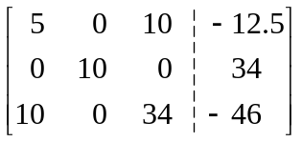

Gaussian elimination:
Step 1a: Get a 1 in the first position of the first row by dividing the row by 5:
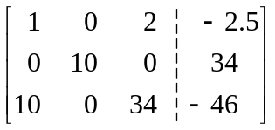

Step 1b: Get a 0 in the first position of the second row – already done
Step 1c: Get a 0 in the first position of the third row by adding -10 of the first row:
First row * -10 = [-10 0 -20 25] added to third row (above) gives:
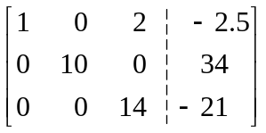Note that steps 1a, 1b, and 1c can be combined in one step.

Step 2a: Get a 1 in the second position of the second row (the pivot position in the second row, along the diagonal) by dividing the row by 10:
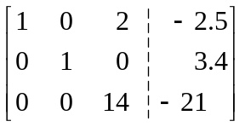

Step 2b: Get a 0 in the second position of the first row – already done
Step 2c: Get a 0 in the second position of the third row – already done
Again, note that the original data used was selected to make our calculations easier – most of the time, these steps will not already be done for us. And again, steps 2a-c are often combined in one step, but can be written separately for clarity – don’t be afraid to use paper to show your steps!

Step 3a: Get a 1 in the third position of the third row by dividing the row by 14:
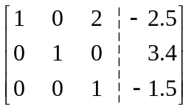

Step 3b: Get a 0 in the third position of the first row by adding –2 of the third row
Third row * -2 = [0 0 -2 3] added to first row (above) gives:
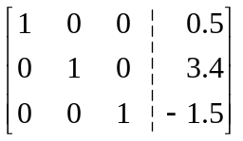

Step 3c: Get a 0 in the third position of the second row – already done

Least-squares polynomial:
The augmented matrix is now in the form of the identity matrix, so the last column now contains the values of the coefficients for the polynomial of degree 2 that best fits our original data points. In particular:
- a₀ = 0.5
- a₁ = 3.4
- a₂ = -1.5

Thus, the polynomial of best fit is:
y = 0.5 + 3.4x - 1.5x²

or from largest to smallest power of x:
y = -1.5 x² + 3.4x + 0.5

Answer – degree 3:
For a degree 3 polynomial of the form y = a₀ + a₁x + a₂x² + a₃x³, we need the x sums up to x⁶ and the y sums up to x³y.

Calculations:
Number of data points: N = 5 (used as the first x sum)

x | y | xy | x² | x²y | x³ | x³y | x⁴ | x⁵ | x⁶
-2 | -13.5 | 27 | 4 | -54 | -8 | 108 | 16 | -32 | 64
-1 | -2.0 | 2 | 1 | -2 | -1 | 2 | 1 | -1 | 1
0 | 0.5 | 0 | 0 | 0 | 0 | 0 | 0 | 0 | 0
1 | 0.0 | 0 | 1 | 0 | 1 | 0 | 1 | 1 | 1
2 | 2.5 | 5 | 4 | 10 | 8 | 20 | 16 | 32 | 64
0 | -12.5 | 34 | 10 | -46 | 0 | 130 | 34 | 0 | 130

Resulting formulas:
As an augmented matrix:
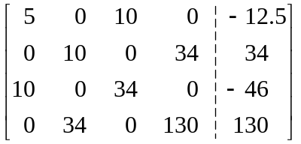

Gaussian elimination:
Step 1: Get a 1 in the first position of the first row by dividing by 5; get a 0 in the first position of every other row; already there for rows two and four, so just add –10 * new first row to row three (above):
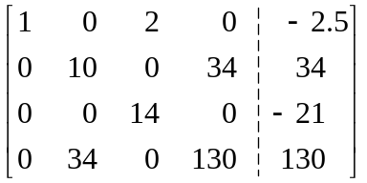

Step 2: Get a 1 in the second position of the second row by dividing by 10; get a 0 in the second position of every other row; already there for rows one and three, so just add –34 * new second row: [0 -34 0 -115.6 -115.6] to row four (above):
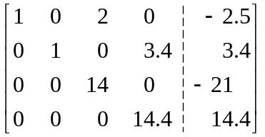

Step 3: Get a 1 in the third position of the third row by dividing by 14; get a 0 in the third position of every other row; already there for rows two and four, so just add –2 * new third row to row one (above):
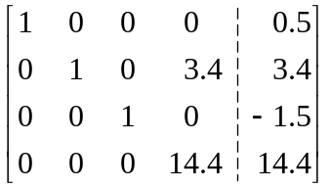

Step 4: Get a 1 in the fourth position of the fourth row by dividing by 14.4; get a 0 in the fourth position of every other row; already there for rows one and three, so just add –3.4 * new fourth row to row two (above):
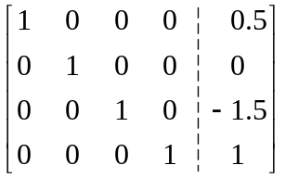

Least-squares polynomial:
The augmented matrix is now in the form of the identity matrix, so the last column now contains the values of the coefficients for the polynomial of degree 3 that best fits our original data points. In particular:
- a₀ = 0.5
- a₁ = 0
- a₂ = -1.5
- a₃ = 1

Thus, the polynomial of best fit is:
y = 0.5 + 0x - 1.5x² + 1x³
or
y = 0.5 - 1.5x² + x³

or from largest to smallest power of x:
y = 1x³ - 1.5x² + 0x + 0.5
or
y = x³ - 1.5x² + 0.5

Note: when you use your code to find the coefficients, you may not get a₁ = 0; instead, you may get a result like a₁ = 1E-13. Does this show that the answers above are wrong, or that your code is wrong? If not, can you explain the results?

